Day – 2 Assignment

Open Wireshark, capture network traffic while you refresh the Flipkart homepage, and identify one packet each belonging to the Application, Transport, Internet, and Network Access layers by examining their headers.
Ans :
Wireshark Practical – Flipkart
1. Application Layer
- Look for a DNS or TLS/HTTP packet.
- Example: DNS
- Header/detail to check: Queries → flipkart.com
- Purpose: Converts flipkart.com into an IP address.
2. Transport Layer
- Look for a TCP packet.
- Header/detail to check: Source Port, Destination Port, Sequence Number, Flags
- Example: TCP → Destination Port: 443
- Purpose: Provides communication between your device and the web server.
3. Internet Layer
- Look for an IPv4/IPv6 packet.
- Header/detail to check: Source IP, Destination IP, TTL
- Purpose: Provides IP addressing and routes packets toward the Flipkart server.
4. Network Access Layer
- Look for an Ethernet or 802.11 (Wi-Fi) packet.
- Header/detail to check: Source MAC, Destination MAC
- Purpose: Sends the packet across the local network between your laptop and router.
Answer you can submit
TCP/IP Layer | Packet/Protocol | Header information checked | What it does
Application | DNS | Query: flipkart.com | Finds the website's IP address
Transport | TCP | Ports, Flags, Sequence Number | Provides transport communication
Internet | IPv4 | Source/Destination IP, TTL | Provides addressing and routing
Network Access | Ethernet/Wi-Fi | Source/Destination MAC | Transfers data over the local network

Create a table comparing the OSI and TCP/IP models, listing all layers side-by-side, and for each layer, give a real-world example from any app you use (e.g., WhatsApp message, Zomato order).
Ans :
OSI Model | TCP/IP Model | Main Function | Real-World Example
7. Application | Application | Provides network services to users/apps | 📱 WhatsApp message
6. Presentation | Application | Encryption, compression and data format | 📸 Instagram image encryption/format
5. Session | Application | Establishes and manages communication sessions | Google Meet video session
4. Transport | Transport | Reliable delivery and flow control | Zomato order data using TCP
3. Network | Internet | IP addressing and routing | Google Maps data routed using IP
2. Data Link | Network Access | MAC addressing and frames | Wi-Fi connection between phone and router
1. Physical | Network Access | Sends bits through cables or wireless signals | Ethernet cable / Wi-Fi radio signals

Given a screenshot of a TCP segment header (provided by your trainer), label the fields that belong to the Transport layer and explain what each field does in 1-2 lines.<br><br><em><strong>Hint:</strong> Look for fields like Source Port, Destination Port, Sequence Number, etc.</em>
Ans :
TCP Header Field | What it does
Source Port | Identifies the application/process that sends the data.
Destination Port | Identifies the application/process that should receive the data.
Sequence Number | Keeps track of the position of data so TCP can put segments in the correct order.
Acknowledgment Number | Tells the sender which data has been successfully received.
Header Length (Data Offset) | Shows the size of the TCP header and where the actual data begins.
Flags | Control the TCP connection. Examples: SYN starts a connection, ACK confirms data, and FIN closes the connection.
Window Size | Tells how much data the receiver can accept, helping control data flow.
Checksum | Checks whether the TCP header and data were corrupted during transmission.
Urgent Pointer | Points to urgent data when the URG flag is used.
Options | Provides additional TCP features, such as maximum segment size and timing information.

Draw a diagram showing how a message sent from your device to Instagram's server passes through each TCP/IP layer, and annotate what happens at each step using simple app-related terms (e.g., 'message split into packets', 'IP address added', etc.).
Ans :

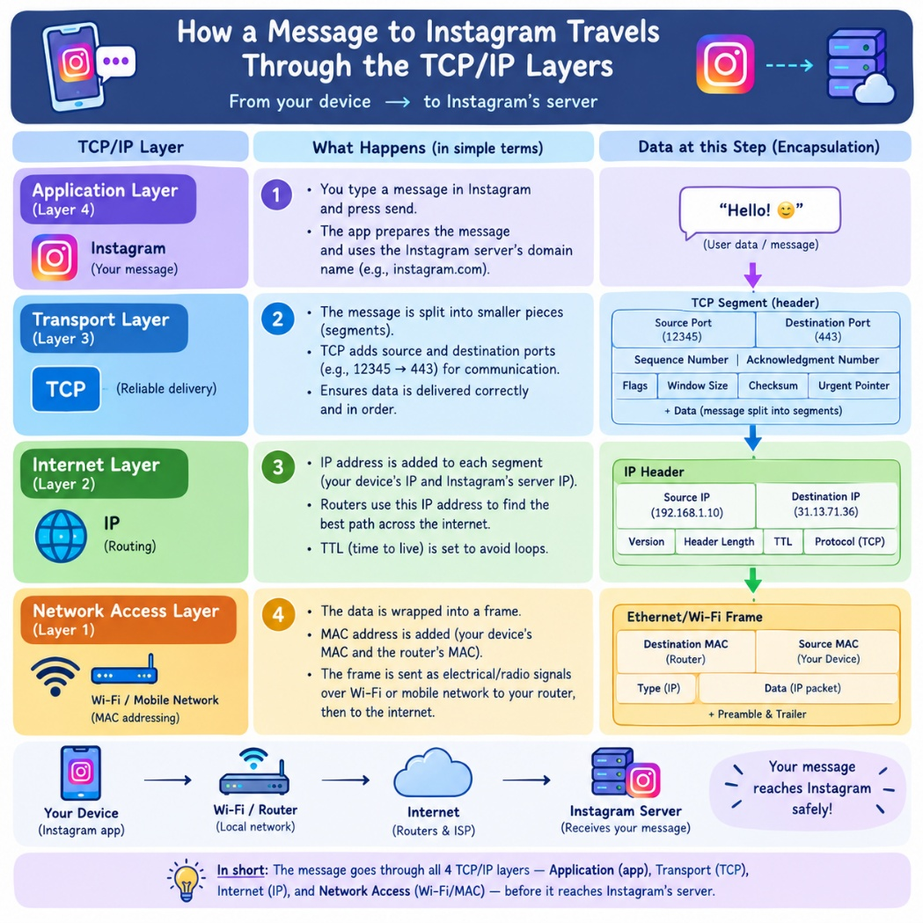

Pick any one packet you captured in Wireshark and write which TCP/IP layer it belongs to, how you identified it, and what real-world action in an app (like sending a WhatsApp message or booking a ticket on BookMyShow) it represents.
Ans :
Point | Answer
TCP/IP Layer | Transport Layer
Protocol | TCP
How I identified it | I checked the Protocol column in Wireshark, where the packet was shown as TCP. In the packet details, I could see fields such as Source Port, Destination Port, Sequence Number and Flags.
Real-world action | Sending a message on WhatsApp
What happens | TCP helps transport the message data between the device and the WhatsApp server reliably and in the correct order.

